SSY130, Applied Signal Processing

Project 1A
Acoustic Communication System

Group 8
Secret Key: Slaking
DOB: 19880803

Kashif Shabir
Haitham Babbili
Muhammad Haris Khan

Task 1
a)
The received signal before and after the equalization is same given those output in term of error
EVM: 3.03e-16, BER: 0
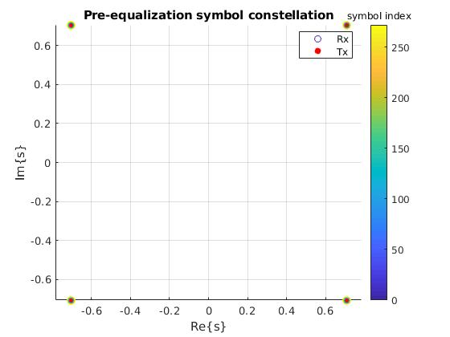
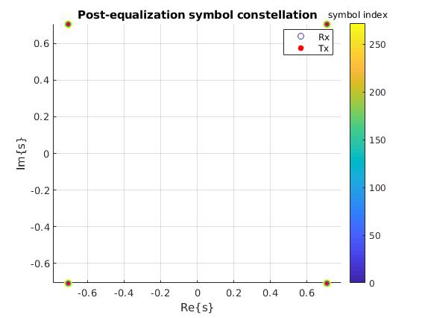

b)
EVM remain the same for any value of N_cp up to length of OFDM symbols, We can’t give N_cp more then length of OFDM symbols.
EVM: 3.03e-16, BER: 0

c)
channel h2, the point are shrink before equalization but became exactly the same after equalization.
Alpha = 0.35355 /0.70711=0.5
EVM: 3.03e-16, BER: 0
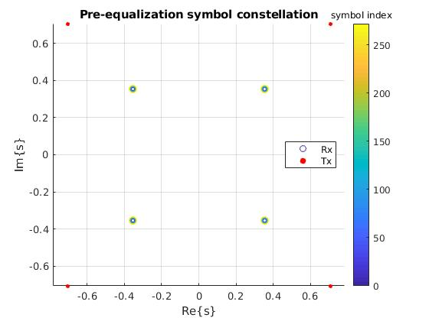
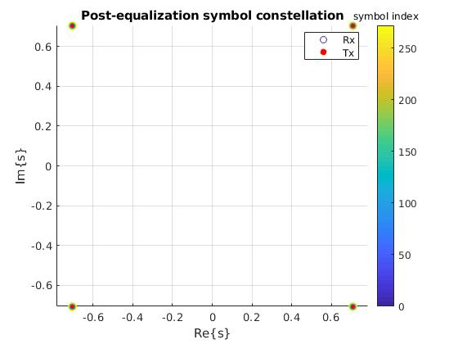
channel h3, the point are rotated anticlockwise before equalization but after equalization they rotate back to original position
Alpha = angel (y) – angle (z) =28 degrees
EVM: 3.6e-16, BER: 0
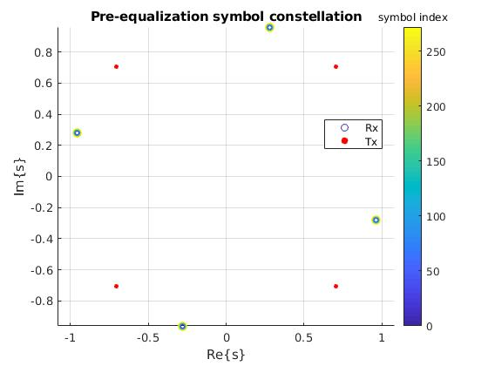
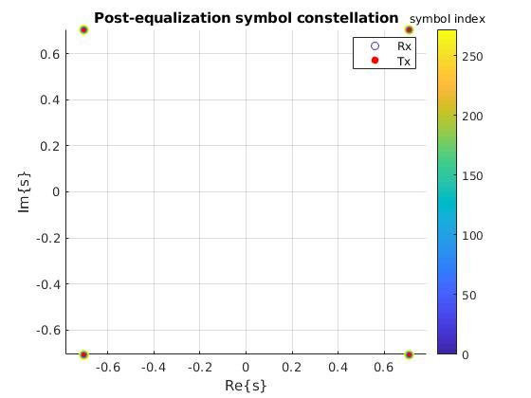

d)
sync=1
Transmitted: 'Alice: Would you tell me, please, which way I ought to go from here?'
Received: 'Alice: W_t62_5_066_40_E_E_E_E_E_m here?'
EVM: 1.4, BER: 0.496

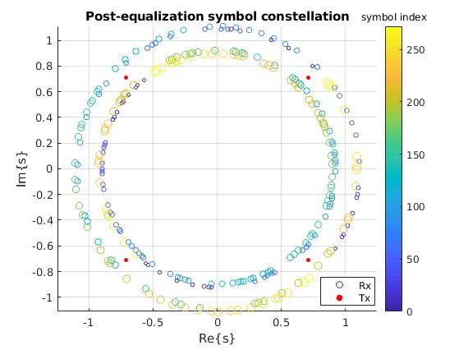
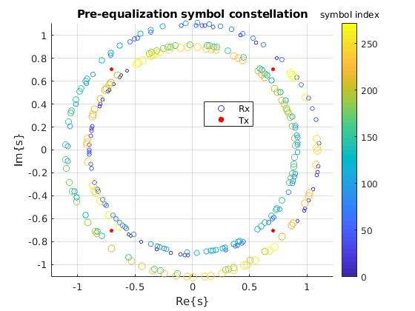

sync=-1
Transmitted: 'Alice: Would you tell me, please, which way I ought to go from here?'
Received: 'Alice: WJ_E_E_E_IE_,_5_1>_5_15_3_om here?'
EVM: 1.41, BER: 0.5

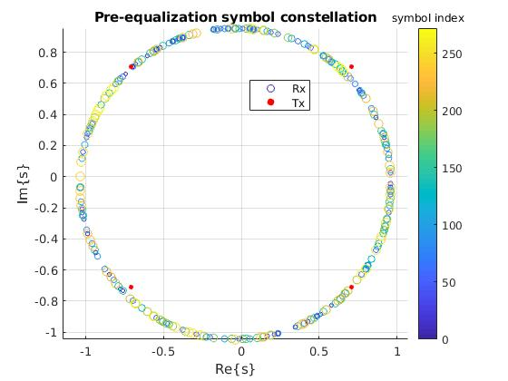
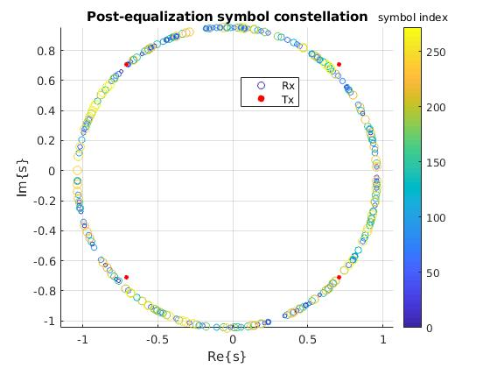

sync=2
Transmitted: 'Alice: Would you tell me, please, which way I ought to go from here?'
Received: 'Alict_5_62_E_IE_e, whic~_8_,_5_E_E_re?'
EVM: 1.41, BER: 0.493

sync=-2
Transmitted: 'Alice: Would you tell me, please, which way I ought to go from here?'
Received: 'AlicG`E_E_40_609se, whicaE_E_E_5_3_54_8%re?'
EVM: 1.41, BER: 0.496

The delay in time means phase shift in frequency and due to this delay (which is actually caused by sync error or vice versa) the BER and EVM increases as compared to no sync error because of imperfect synchronization.

What we found is that the increase in synchronization error increases the frequency equal to length (sync error) which can be corresponded into the different number of message sections. A message is divided into number of sections (due to the length of sync error). And every time the start and end of the each section remains unchanged because of the added cycling prefix. Concisely it means sync error correspond to the length of sections.

e)
SNR=30 there is some nose but still we exactly detected the samples accurately with BER =0
however the received symbols are forming a cloud around the original point because of added random noise.
Transmitted: 'Alice: Would you tell me, please, which way I ought to go from here?'
Received: 'Alice: Would you tell me, please, which way I ought to go from here?'
EVM: 0.0289, BER: 0

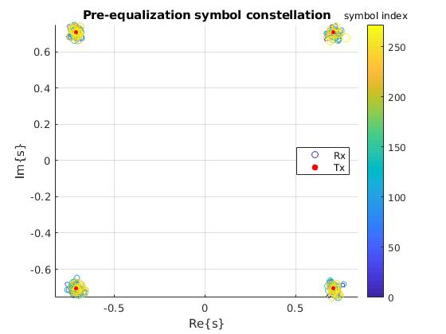
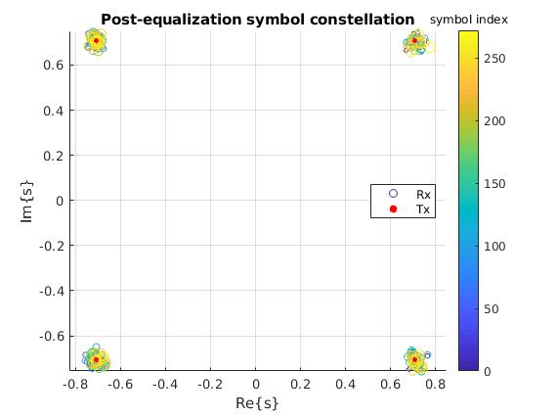

SNR=5 means higher noise power as compared to the signal power since channel is very bad, therefore received symbols are dispersed more as compared to SNR=30. This is the reason we are getting BER=0.0276 which mean we are can not detect every symbol accurately.

Transmitted: 'Alice: Would you tell me, please, which way I ought to go from here?'
Received: 'A|ice8(WOUhd"you tell me$ please< w`ich w@y I"ought"to go from here_'
EVM: 0.515, BER: 0.0276
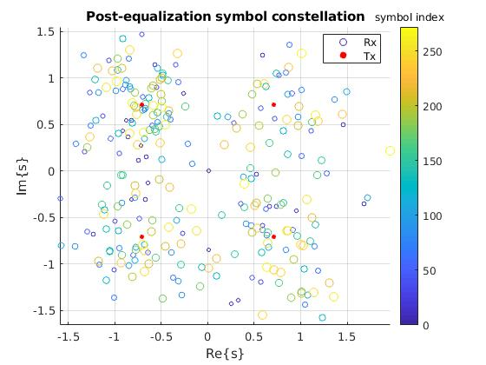
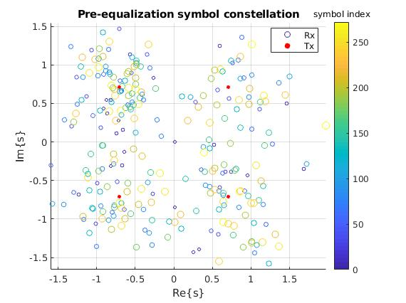

Task 2
a)
We find 3.5(-1+j)point at h(1)= 5 since this is the transmitted point. Broadly, magnitude and phase of the channel changes the constellation points’ magnitude and phase. If phase response decreases then constellation points start rotating clockwise what we observe in the 2nd half of the constellation before equalization. More sharp the increase or decrease the magnitude response corresponds to the less thickness of the constellation points. When magnitude changes slowly and phase increases linearly the constellation points become more thick towards clockwise direction.

b)

EVM: 1.06e-15, BER: 0.158

for N_cp = N
EVM: 1.06e-15, BER: 0.158

for N_cp = N/2
EVM: 1.06e-15, BER: 0.158
N_cp = N/4
EVM: 1.06e-15, BER: 0.158

N_cp = N/6
EVM: 0.0751, BER: 0.162

The magical number that give us EVM less than e-15 is N_cp= N/4
the Evm remain or approximately equal to e-15 at N_cp=N, N/2, N/4; but after decreasing N_cp more than 68, EVM started increasing. So, the magical number is 68 because it is the point which add less redundancy as compared to N/2 to N.

c)
EVM: 4e-15, BER: 0.235
The post equalization diagram shows us that we accurately maps our transmitted symbols but BER telling us a different story that we are detecting 23.5 % wrongly even EVM is very low. This is due to the fact that we wrongly mapped our symbols because the channel is nonlinear.

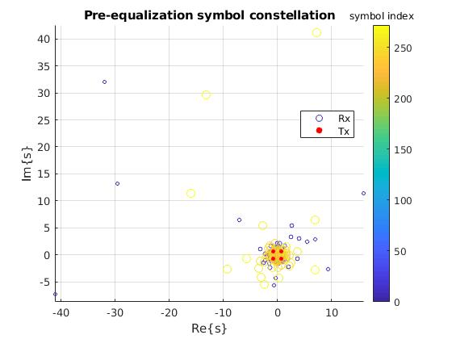
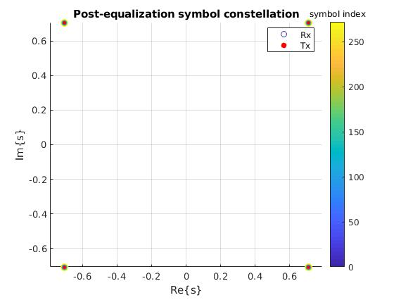
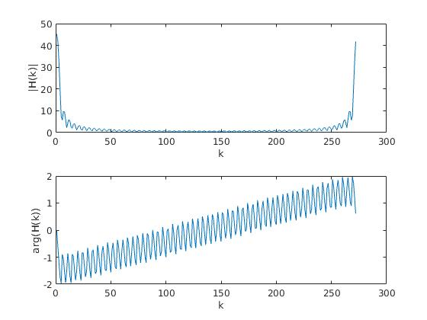

Task 3

a)

Transmitted: 'Alice: Would you tell me, please, which way I ought to go from here?'
Received: 'Mad Hatter: "Why is a raven like a writing-desk?""Have you guessed t'
EVM: 0.164, BER: 0.336

b)
EVM: 5.08e-15, for N, N/2 and N/4 EVM unchanged and less than e-15 for all these values which is similar as what we found for known channel.
For N_cp=N/4 and unknown channel
SNR=30: EVM: 0.492, BER: 0.342
SNR=10: EVM: 2.26, BER: 0.45
SNR=5: EVM: 2.7, BER: 0.474
SNR=0: EVM: 3.72, BER: 0.48

For N_cp=N/4 and known channel
SNR=30: EVM: 0.33, BER: 0.252
SNR=10: EVM: 3.3, BER: 0.43
SNR=5: EVM: 5.86, BER: 0.46
SNR=0: EVM: 10.4, BER: 0.463

At fixed N_cp=N/4 the EVM and SNR for unknown channel is higher as compared to the known channel because for the unknown channel we have to estimate channel who may not be estimated accurately which added some error that is why we are getting higher BER and EVM for unknown channels as compared to known channel.

c)
At N_cp=N/4, SNR= infinity, Unknown Channel, h5 and no synchronization error:
We got these values EVM: 0.289, BER: 0.336 even at high SNR because the channel is multi path and fading will effect the performance because we need to sum the results of both paths, so that is why BER is higher as compared to single path channel.
For h’:
EVM: 6.17e-16, BER: 0.336
The BER remains same for h and h’ but EVM is changing.

NOTE: We perform lot of simulations for known and unknown channels considering single and multi path channels and we found the above results. However, for known channel BER=0 for single path but non zero for multi-path which is logical.

d)
Table.1 Performance for different parameters
SNR | N_cp | Syn error | Unknwon channel  signle path multipath |  | BER/EVM
30 | N/4 | 1 | OK |  | 0.336/0.208
20 | N/4 | 0 |  | ok | 0.336/0.372
10 | 55 | 0 |  | ok | 0.371/1.08
0 | 30 | 1 |  | ok | 0.454/2.39

Looking carefully in the table the channel behavior is very different for different scenarios like for different channels types the BER and received message changes rapidly and this also happen for SNR, N_cp, and sync error. Therefore, overall we can say our system is not robust but its sensitive.

